Follow the steps to apply the promo codes –
https://www.singaporeair.com/en_UK/sg/home#/book/bookflight

scroll down
Click on the APPLY PROMO CODE
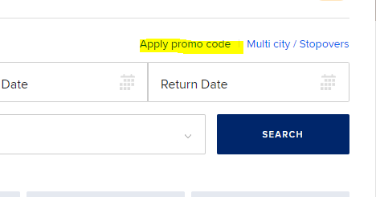

Type the promo code in the box and click on APPLY
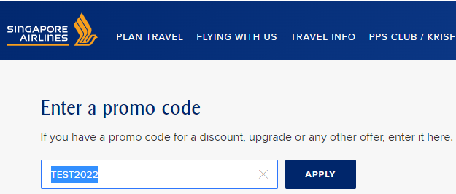

It will go to the landing page, scroll down
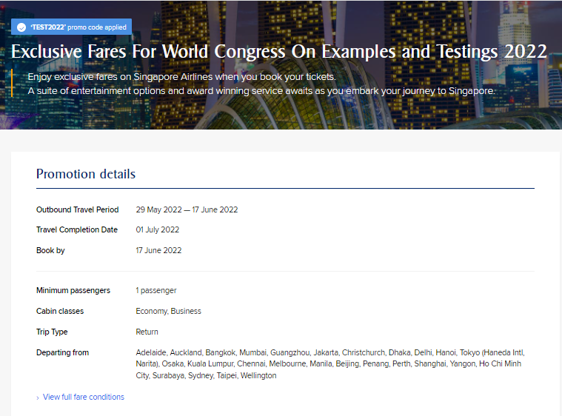

Make your flight bookings here and click SEARCH
For example:
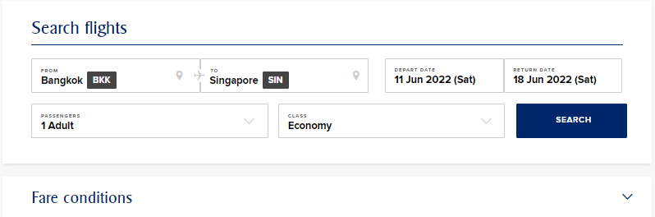

It will go to the flight details page.
On this page, choose your preferred flights
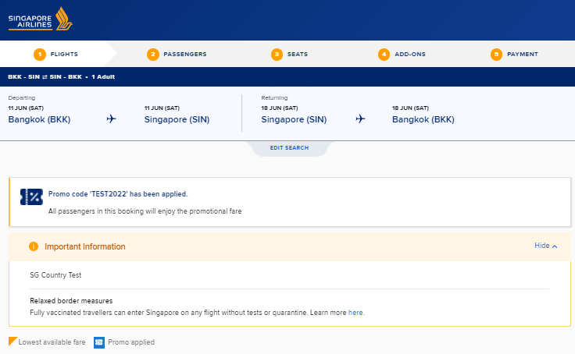

Blue tag indicates promo fares applied
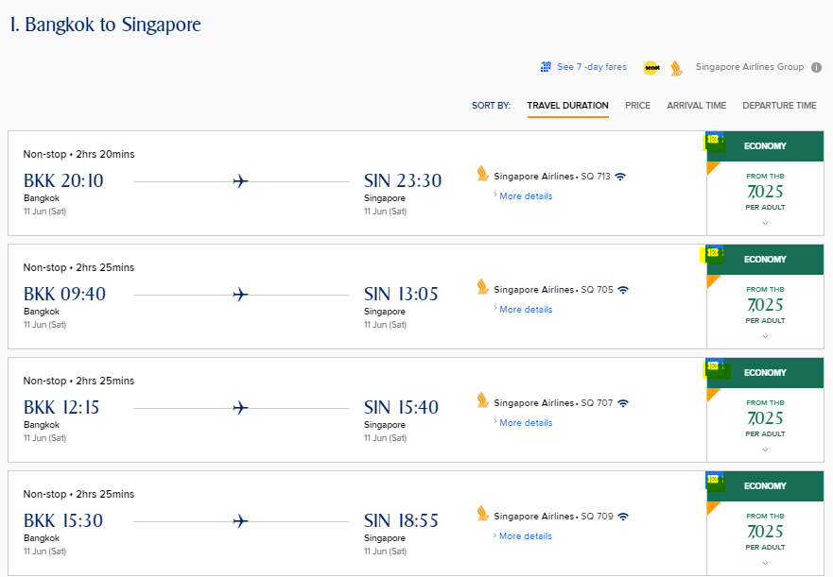
Promo fares showing
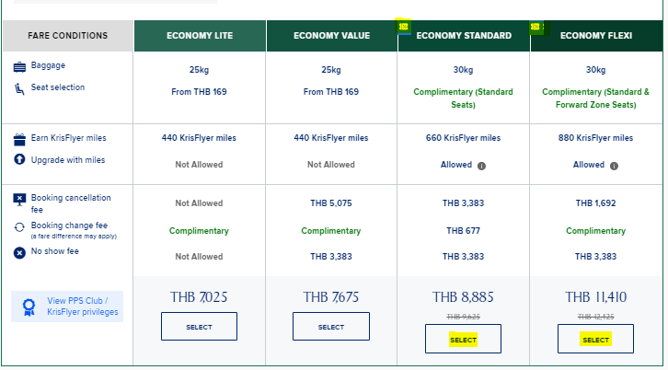
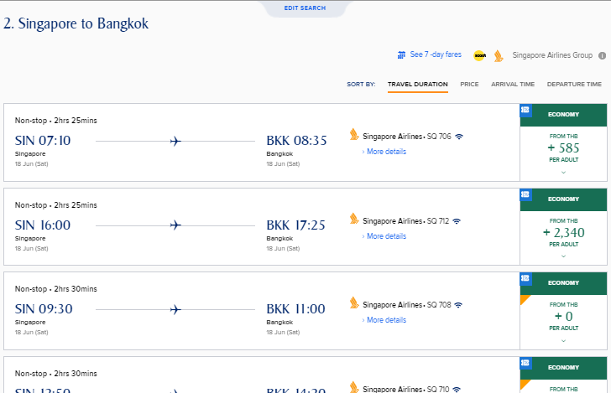

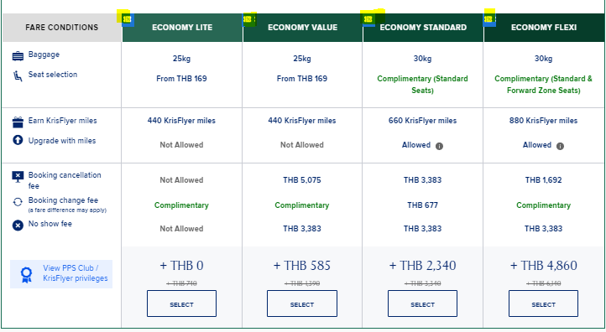

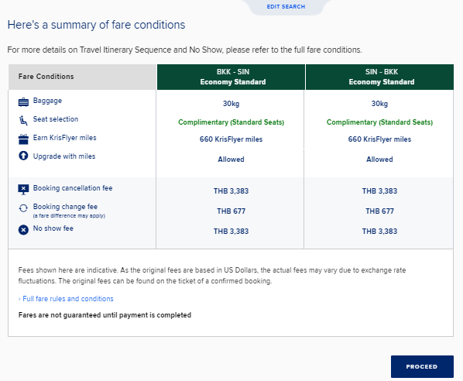
Click on PROCEED.
To go to next page for PASSENGER DETAILS

